Types of Forces
A force is a ______ or a ____________ or a twist on an object.
Examples of Forces.
Gravity. This is the force that pulls objects towards the surface of the Earth.
Magnetics force. A force that pulls a magnetic material towards a magnet.
Tension. This is the force that is transmitted through a string, rope, cable or wire when it is pulled tight by forces acting from opposite ends.
Impact. The force when two objects crash into each other.
Friction. The Force that tries to stop one surface moving over another.
Buoyancy. The upward force on an object in water. It pushes the object up and helps it float.
Some forces have to have the objects involved touching (contact forces).
Some forces can act on objects without touching the objects (action at a distance force).

Contact Forces | Action at a distance force
Frictional Force  Tension Force  Impact  Buoyancy | Gravitational Force  Magnetic Force

Example | Name of force | Contact or action at a distance force?
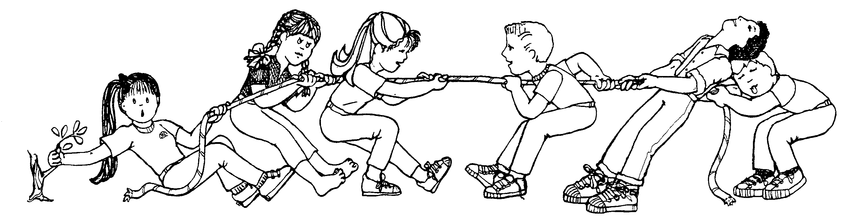
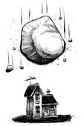
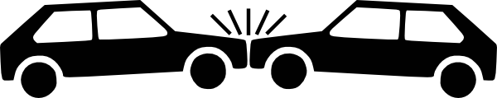
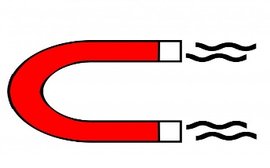
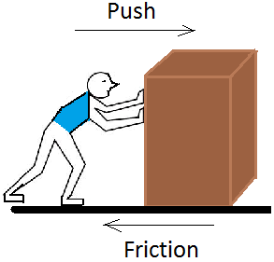
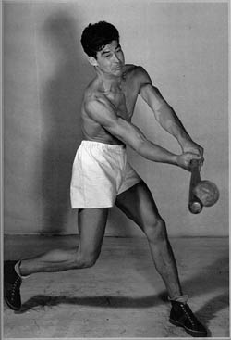
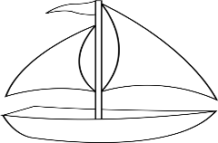

Balanced and Unbalanced forces.
Sometimes we can have two or more forces acting on an object at the same time. These forces can be trying to move the object in different directions.
If these two opposite forces are equal we say that there is balanced forces. When the forces are balanced the objects motion will not change. The boat in the picture will float because the upward buoyance force is equal to the downward force of weight.
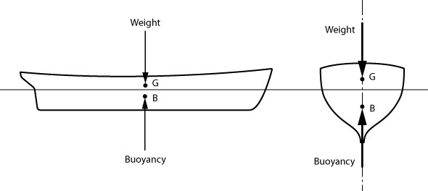
If the forces are unbalanced the objects motion will be changed. If the weight on the boat above gets too big the boat will sink.
Unbalanced forces can cause an object to start ______________, or ___________ up, or ___________ down, or stop moving or change _________________.
Look at the diagram below and use it to answer the questions that follow.
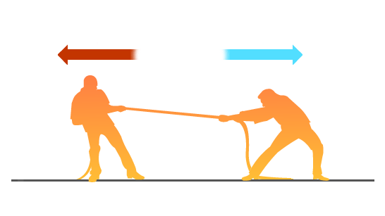
Are these forces balanced?

How will the motion of the two men change?
Inertia= The tendency for an object to resist a change its _______________.

Isaac Newtons first law of motion
Isaac Newton’s first Law of motion states:
-___________________________________________________________________________________________________________________________________________________________________________________________________________________________________________
-
________________________________________________________________________________________________________________________________________________________________________________

